Puchheim, 29 July 2019

STEMMER IMAGING and MVTec expand co-operation into the UK and Ireland

STEMMER IMAGING AG and MVTec Software GmbH are expanding their co-operation for the distribution of HALCON and MERLIC machine vision software to include the United Kingdom and Ireland. This will take effect from 1st September 2019, and further builds on the current distribution agreement between the two companies which already covers 14 European countries.
MVTec HALCON is a well-established machine vision software with an integrated development environment that allows the rapid and cost-effective creation of machine vision applications. This provides an ideal platform for systems integrators or for building OEM vision solutions or vision sub-systems. Its ability to be ported to various processors/DSPs, operating systems, and compilers also makes it well suited for the development of embedded vision solutions. MVTec MERLIC is an all-in-one software that can be used to build machine vision solutions without programming.
Mark Williamson, Managing Director, STEMMER IMAGING Ltd, commented: “We are delighted to be able to offer HALCON and MERLIC in the UK and Ireland, to enhance our existing software portfolio. STEMMER IMAGING customers will benefit from access to MVTec’s leading software tools with rich functionality in both 2D and 3D applications as well as their state of the art deep learning capability. We are also pleased to announce that MVTec will be taking part in our UK Vision Technology Forum which takes place at The Vox Centre, Birmingham, 13 – 14 November, 2019.”

Gerhard Wagner, Sales Director EMEA at MVTec, said: “With the well-established relationship with STEMMER IMAGING in many parts of Europe, we are now looking forward to working with this strong sales channel in the UK and Ireland. They have a sizeable and knowledgable local technical team who are able to provide enhanced support and development services capabilities for OEM customers, machine builders, and systems integrators. This ensures that our software will be used in an even wider range of projects than ever before.”

approx. 2.092 characters (incl. spaces)

Image:

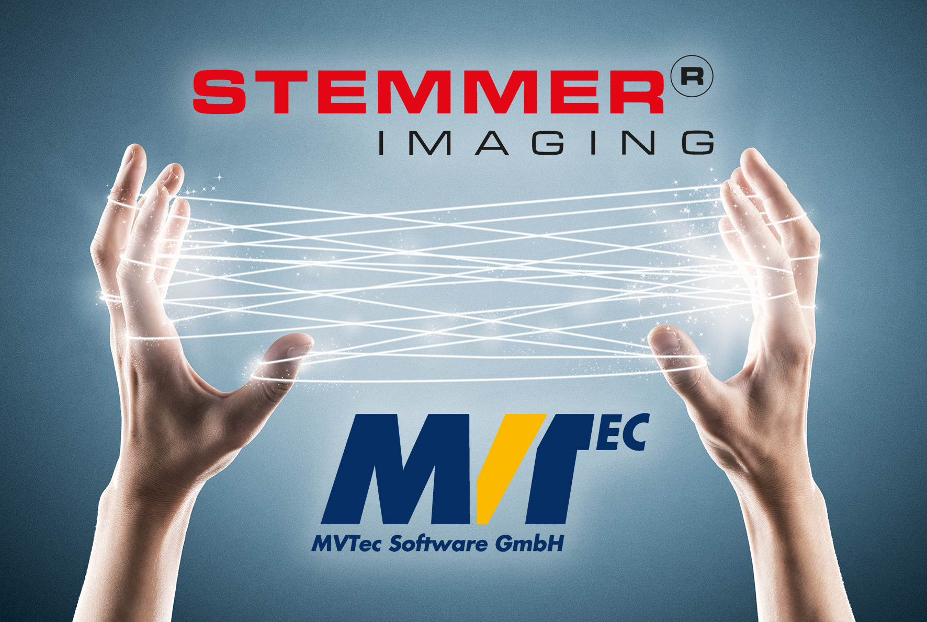
STEMMER IMAGING and MVTec expand their co-operation.
press_release_stemmer_mvtec.jpg
Image Source: STEMMER IMAGING

All company and product names mentioned in the text may be trademarks or registered trademarks of the respective companies.

About STEMMER IMAGING:
STEMMER IMAGING is one of Europe’s leading machine vision technology providers for science and industry. With a perfect combination of innovative products, expert advice and comprehensive service, STEMMER IMAGING helps clients solve their machine vision tasks securely with speed and ease. Experienced specialists can be contacted easily and are available to provide local advice throughout Europe.

About MVTec Software GmbH:
MVTec is a leading manufacturer of standard software for machine vision. MVTec products are used in all demanding areas of imaging: Semi-conductor industry, web inspection, quality control and inspection applications in general, medicine, 3D vision, and surveillance. MVTec, with its head office in Munich (Germany), has more than 30 established distributors worldwide and in addition, MVTec, LLC works out of Boston, MA (USA). www.mvtec.com

Further information:
STEMMER IMAGING AG
Gutenbergstr. 9-13
82178 Puchheim/Germany
Phone: +49 89 80902-229
info@stemmer-imaging.de
www.stemmer-imaging.com

Press contact:
Local contacts can be found in the online newsroom of the respective STEMMER IMAGING subsidiary.

MVTec press contact:

MVTec Software GmbH
Press Requests
Arnulfstraße 205
80634 München
Phone: +49 89-457695-0
press@mvtec.com
www.mvtec.com

Schwartz Public Relations
Jörg Stelzer
Sendlinger Straße 42 A
80331 München
Phone: +49 89-211 871 -34
mvtec@schwartzpr.de
www.schwartzpr.de/en/

